**Task on VPC-01.**

1) Create VPC with 2 private and 2 public subnets 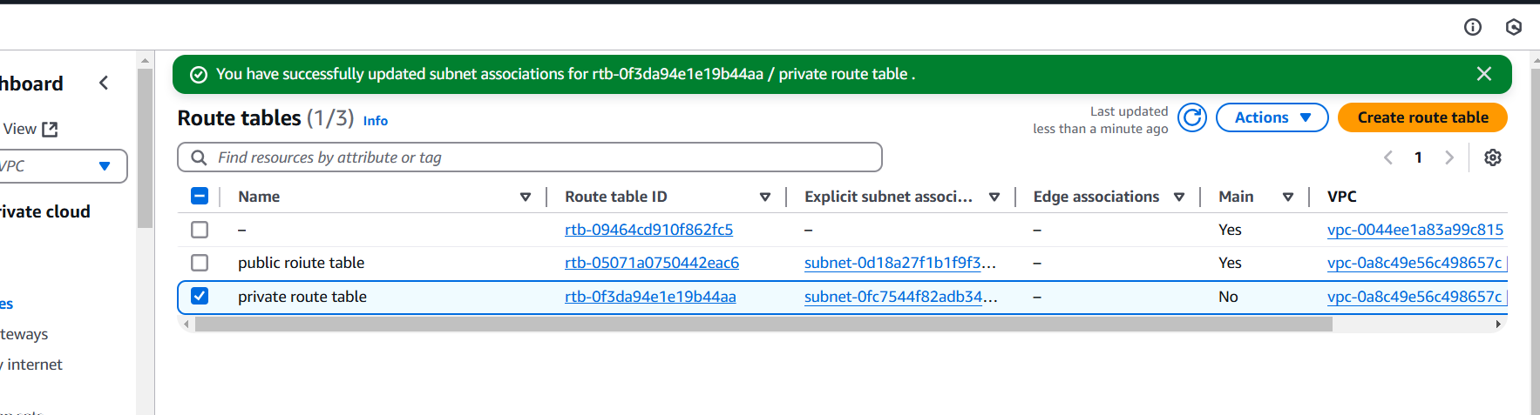

2) Enable DNS Hostname in VPC*

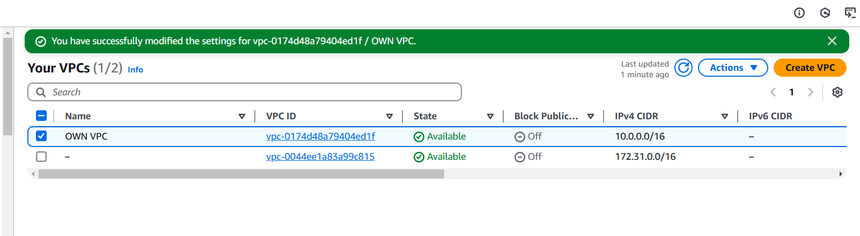

|  |  |
| --- | --- |
| Below is the DNS HOST NAME  ec2-18-218-42-61.us-east-2.compute.amazonaws.com | 18.218.42.61 |

Status showing ec2 DNS HOTNAME IN VPC



Now my ec2 is in stop status , I will start my EC2 by using instance id hostname



aws ec2 stop-instances --instance-ids i-045a19ab9cd6c6543



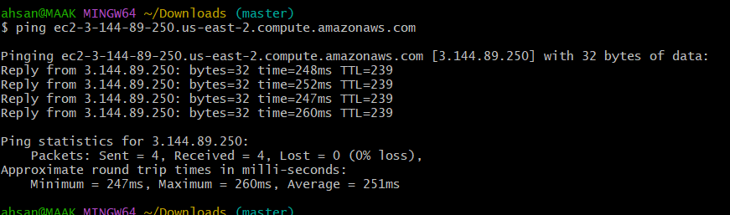

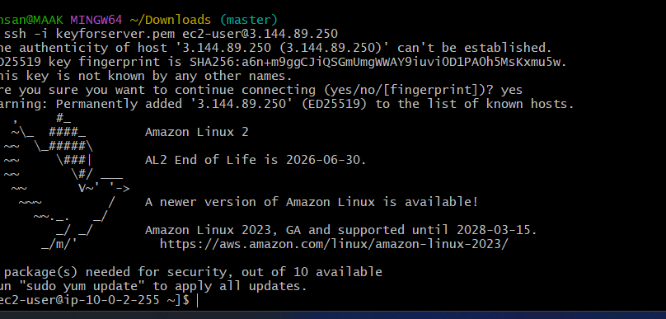

3) Enable Auto Assign Public ip in 2 public subnets

**Rename one public route to newly created vpc TOKYO, and created one private route table**

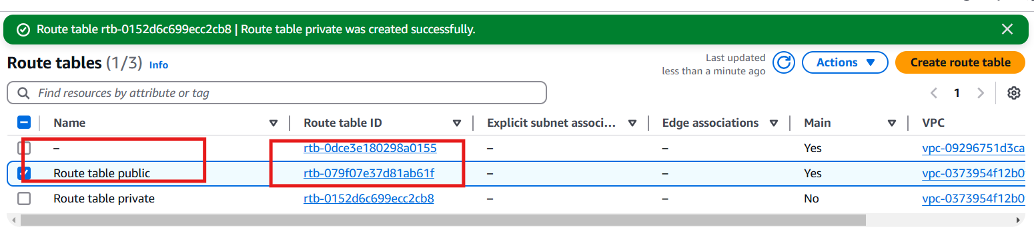

4) Add 2 private subnets in private route table

**One Public subnet and one private subnet.**

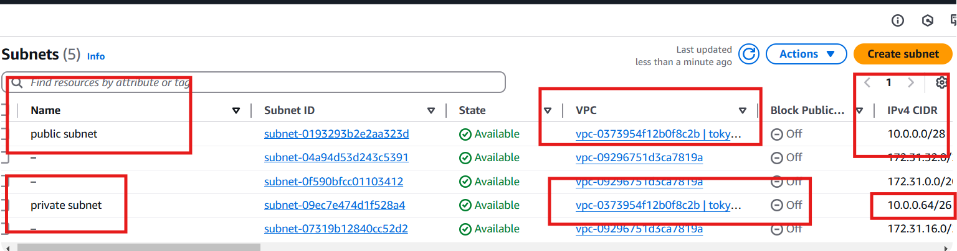

5) Add 2 public subnets in public route table



6) Public route table will have the routes to internet and local

7) Create Ec2 in public subnet with t2micro and install php*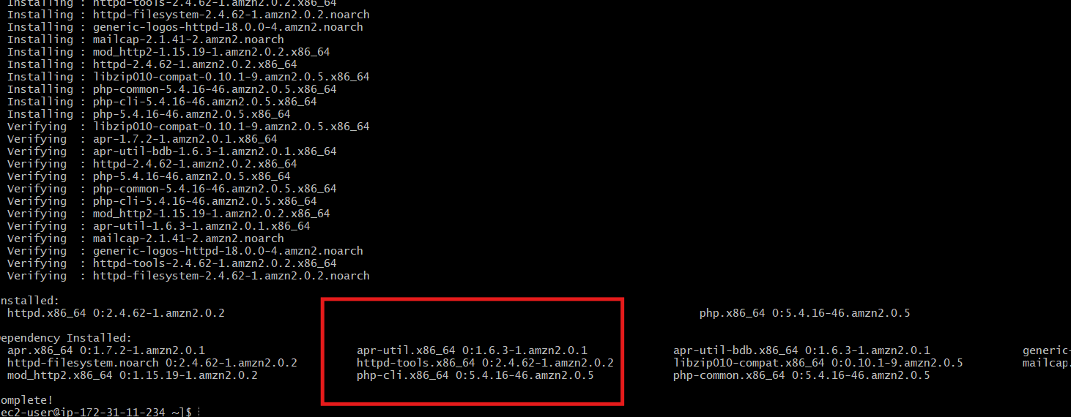





Now, when you visit your EC2 instance's public IP address in a web browser, you should see the PHP info page, which confirms that PHP is installed and running.

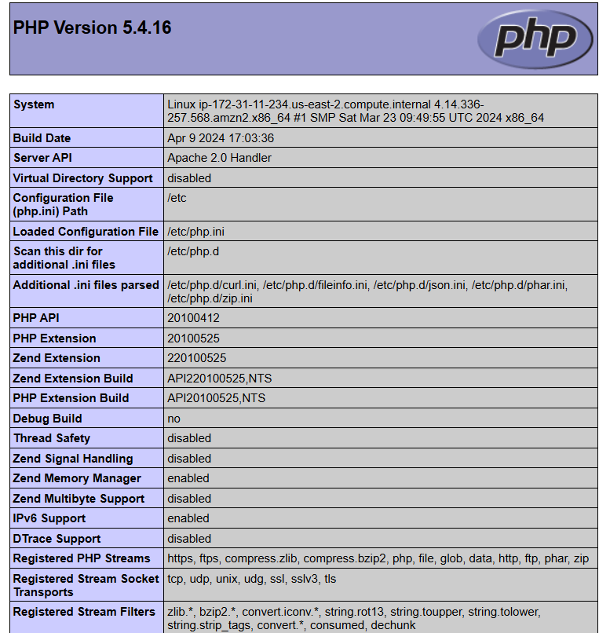

8) COnfigure Nat gateway in public subnet and connect to private Instance

9) Install Apache Tomcat in private ec2 and deploy a sample app.*

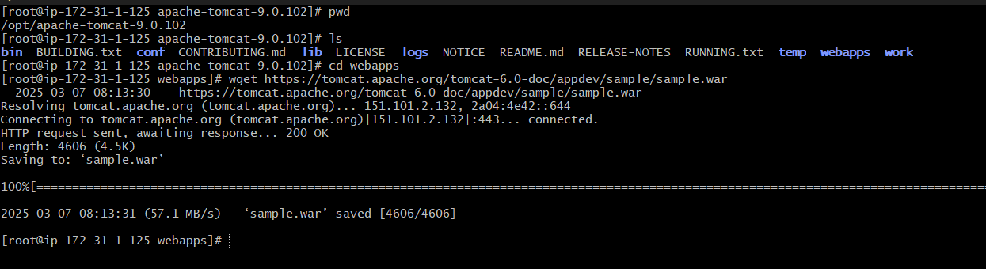

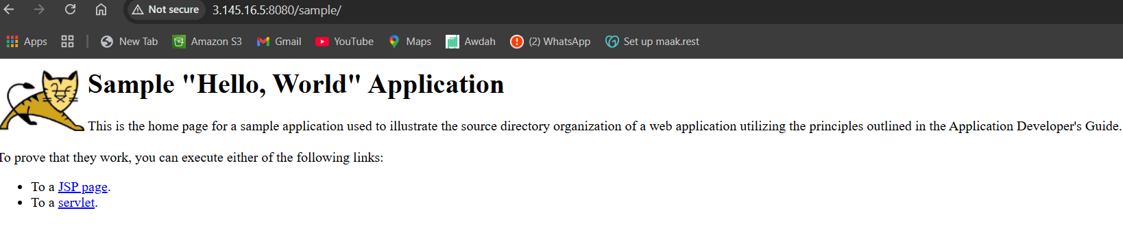

10) Configure VPC flow logs and store the logs in s3 and CloudWatch.*

In this we creating role and give permission to ec2 to allow flow logs in s3 bucket and cloud watch using , create role command in aws .

It means making communication services between ec2 and s3 and cloutwatch with role and permissions

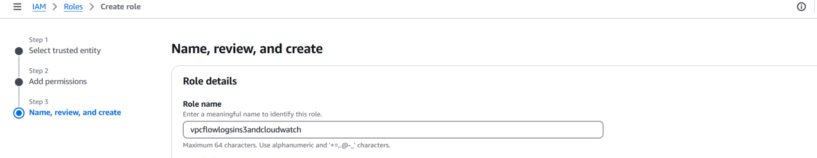

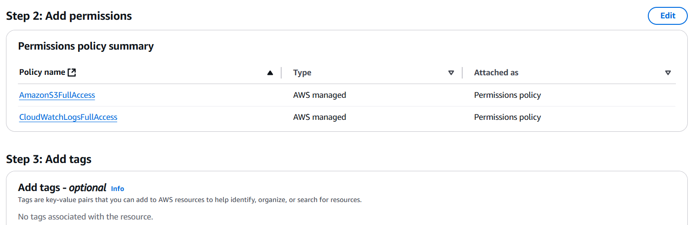

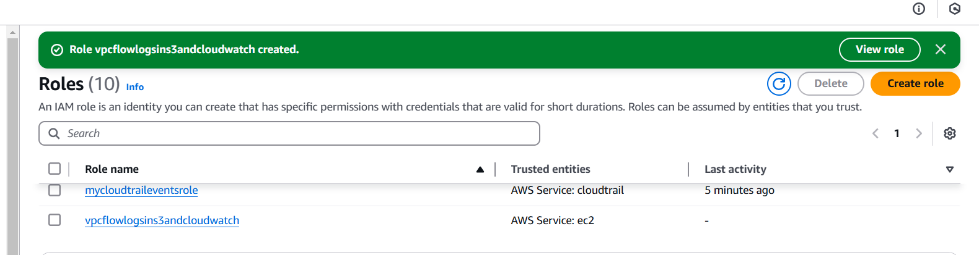

Now one bucket created

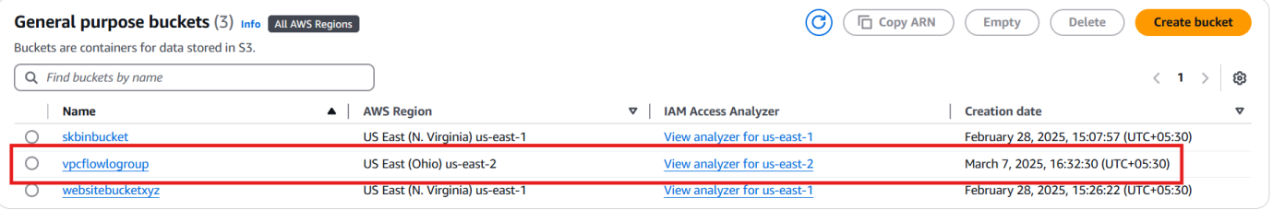

Now created follow log by using myownvpc

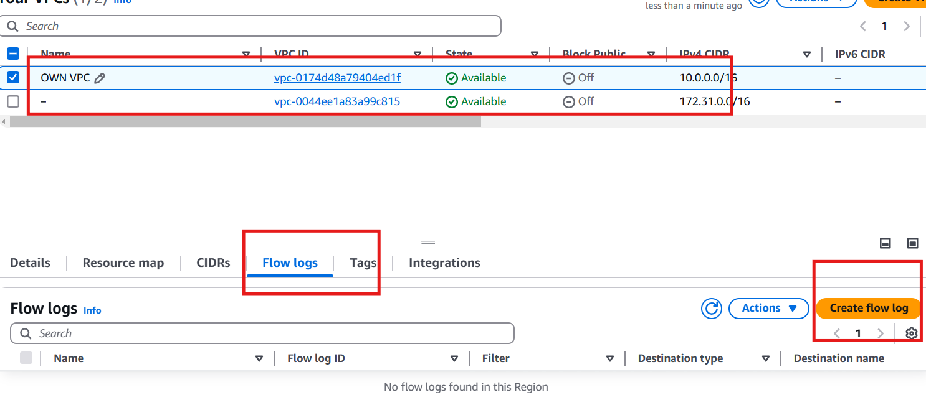

Now create an I AM ROLE

Give a permission to resousre to ec2 to all resources and s3 all resoues and cloud watch all resoures

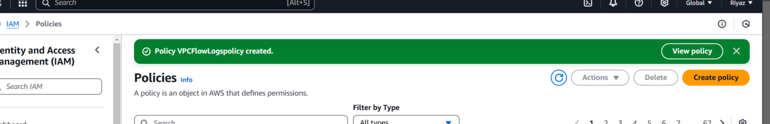

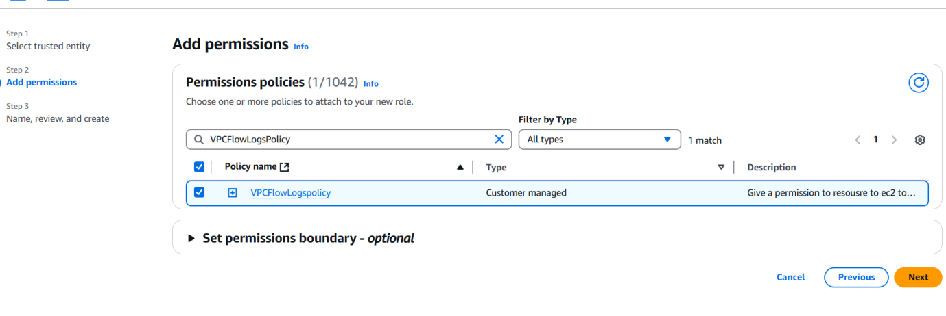

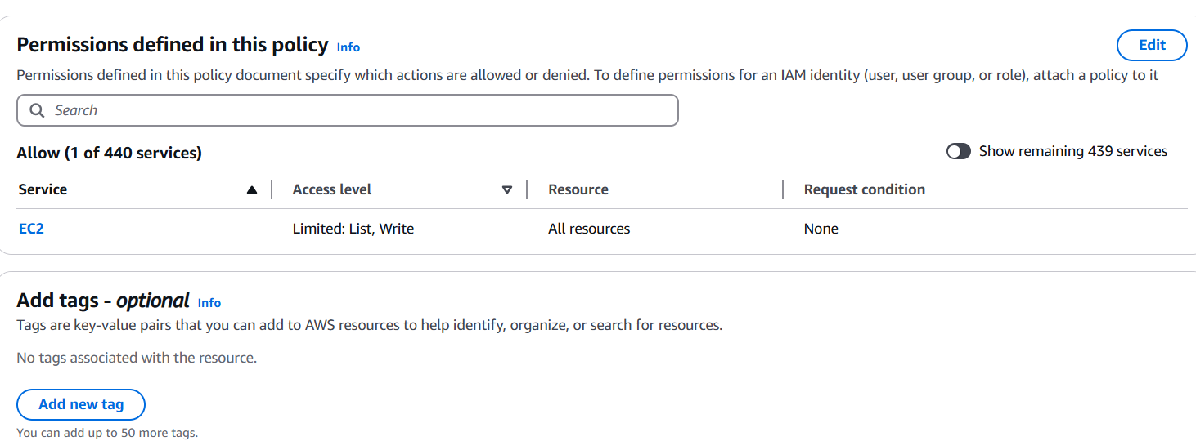

Vpc flow log group created

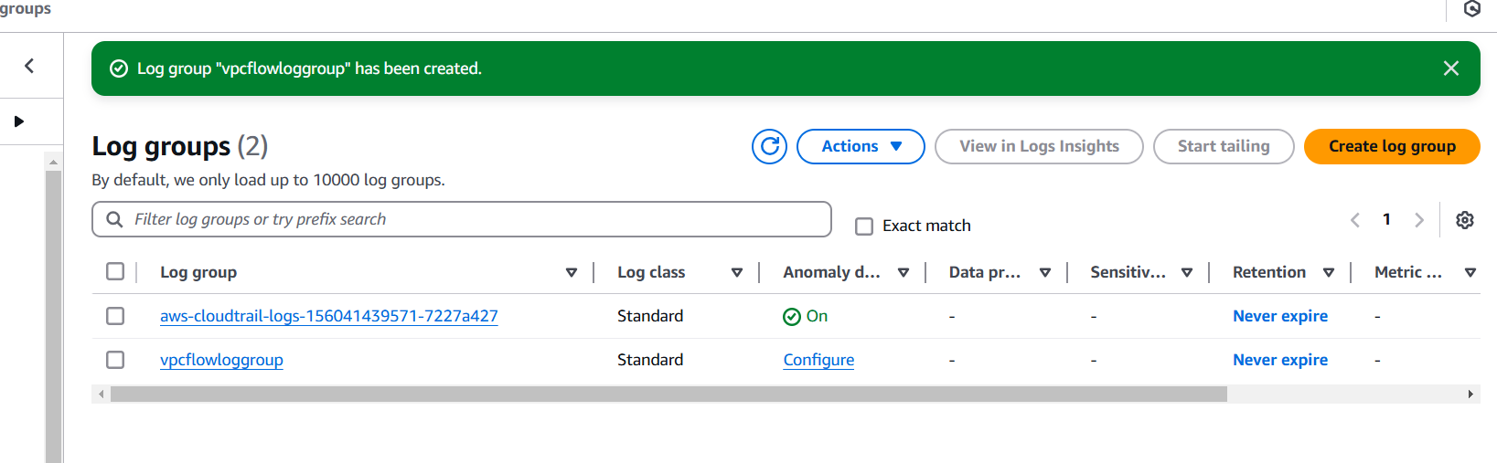

In vpc console copy paste arn number of s3 bucket

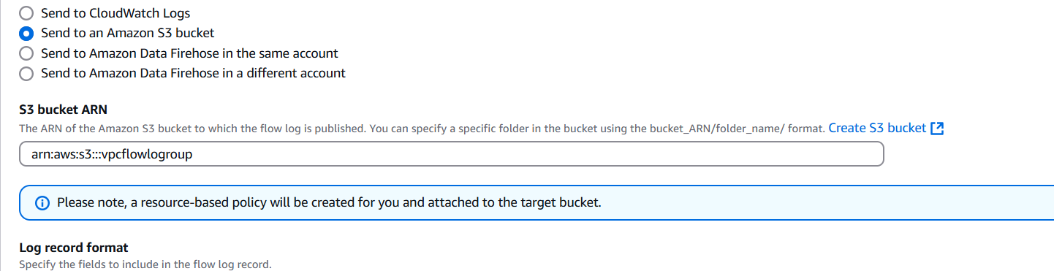

In this selected the role which I have creatred role name

